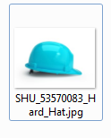

Caption ID of Parent: 1483974

Source: Shutterstock

Source ID: 53570083

Rights Type: Royalty Free

Credit: © Karen Katrjyan/Shutterstock.com

K12 Credit: Cyan hard hat. © Karen Katrjyan/Shutterstock.com

RM Assets Embedded: No

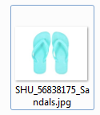

Caption ID of Parent: 1483975

Source: Shutterstock

Source ID: 56838175

Rights Type: Royalty Free

Credit: © S.A.S Photography/Shutterstock.com

K12 Credit: Teal sandals. © S.A.S Photography/Shutterstock.com

RM Assets Embedded: No

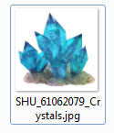

Caption ID of Parent: 1483976

Source: Shutterstock

Source ID: 61062079

Rights Type: Royalty Free

Credit: © Kompaniets Taras/Shutterstock.com

K12 Credit: Cyan crystals. © Kompaniets Taras/Shutterstock.com

RM Assets Embedded: No

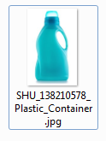

Caption ID of Parent: 1483977

Source: Shutterstock

Source ID: 138210578

Rights Type: Royalty Free

Credit: © Petr Malyshev/Shutterstock.com

K12 Credit: Plastic bottle. © Petr Malyshev/Shutterstock.com

RM Assets Embedded: No

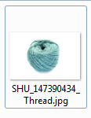

Caption ID of Parent: 1483978

Source: Shutterstock

Source ID: 147390434

Rights Type: Royalty Free

Credit: © Tarzhanova/Shutterstock.com

K12 Credit: Cyan yarn. © Tarzhanova/Shutterstock.com

RM Assets Embedded: No

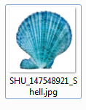

Caption ID of Parent: 1483979

Source: Shutterstock

Source ID: 147548921

Rights Type: Royalty Free

Credit: © Madlen/Shutterstock.com

K12 Credit: Sea shell. © Madlen/Shutterstock.com

RM Assets Embedded: No

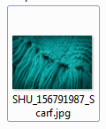

Caption ID of Parent: 1483980

Source: Shutterstock

Source ID: 156791987

Rights Type: Royalty Free

Credit: © Adisa/Shutterstock.com

K12 Credit: Scarf. © Adisa/Shutterstock.com

RM Assets Embedded: No

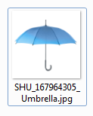

Caption ID of Parent: 1483981

Source: Shutterstock

Source ID: 167964305

Rights Type: Royalty Free

Credit: © Pincarel/Shutterstock.com

K12 Credit: Cyan umbrella. © Pincarel/Shutterstock.com

RM Assets Embedded: No

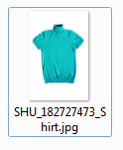

Caption ID of Parent: 1483982

Source: Shutterstock

Source ID: 182727473

Rights Type: Royalty Free

Credit: © Tarzhanova/Shutterstock.com

K12 Credit: Cyan shirt. © Tarzhanova/Shutterstock.com

RM Assets Embedded: No